WestJet Sustainable Aviation Fuel (BioJet) Challenge
Sponsored by Alberta Innovates and WestJet

1.0 Program Overview
In December 2017, the Government of Alberta published the Climate Change Innovation and Technology Framework (CCITF) as the overarching guide for the governments’ investment in innovation and technology to reduce greenhouse gas emissions, while preparing our province for the lower carbon economy of tomorrow. Building upon the success of the Alberta Small Business Innovation and Research Initiative (ASBIRI), a dedicated Clean Technology Commercialization (CT Comm) program has been developed. The CT Comm program seeks to work with industry partners to identify key industry sector needs with the view of having Alberta Small and Medium Enterprise companies provide innovative and novel technological solutions to the defined need.

Alberta Innovates is pleased to announce, in partnership with WestJet, that the CT Comm program is sponsoring the WestJet BioJet Challenge.

Alberta Innovates and WestJet in combination with Small Medium Enterprise (SME) applicant partners will deploy up to $2,000,000.00 for a demonstration, pilot plant, or commercialization of a bioconversion technology(s), that can use Alberta sourced feedstock, leading to the manufacturing of a sustainable, certifiable, economically viable aviation fuel or ‘BioJet’.

2.0 Industry Partner Overview

2.1. WestJet
WestJet is a Canadian airline, based in Calgary, Alberta, with expanding global operations. Through scheduled flights across a growing network, WestJet also operates WestJet Vacations, WestJet Encore, a regional airline which operates a fleet of turboprop aircraft in a network of destinations in Canada and the United States, and Swoop, an ultra-low-cost carrier (ULCC) which commenced operations on June 20, 2018.
As of June 30, 2018, WestJet offered scheduled service to over 100 destinations in North America, Central America, the Caribbean and Europe with a fleet of 115 Boeing 737 Next Generation (Boeing 737 NG) aircraft, seven Boeing 737 MAX (Boeing MAX) aircraft, 47 Bombardier Q400 (Q400) aircraft and four Boeing 767 300ERW (Boeing 767) aircraft. When including connectivity through WestJet’s airline partners, WestJet serves over 175 destinations.

WestJet is committed to growing responsibly and being a leader in the transition to low carbon and sustainable air travel. WestJet takes care of the environment by committing to meet the requirements of environmental regulations, implement environmental management processes that control and minimize environmental impacts, and continuously improve environmental performance through regular reviews and evaluations following WestJet’s environmental policy.

WestJet has taken considerable steps in reducing our impact on the climate by investing in the most fuel-efficient fleet at the time of purchase and continuously focusing on improving the operational efficiency of our aircraft and ground operations. Since 2000, WestJet has improved fuel efficiency by more than 46% by investing more than $5.1 billion on new aircraft fleets and technology such as winglets and required navigation procedures.

3.0 Challenge Overview

3.1 Background
In 2017, WestJet used more than 1.5 billion Litres of aviation fuel and generated more than 3.8 million tonnes of greenhouse gas emissions. Aviation fuel is a significant cost to WestJet (and airlines in general) and represents more than 25% of WestJet’s total annual costs.

Aviation fuel is a specialized type of petroleum derived fuel used to power aircraft. It is of a higher quality than those fuels used in less critical applications such as heating or road transport. It is a complex blend of hydrocarbons such as paraffins, isoparaffins, cyclic and aromatic hydrocarbons. Petroleum based jet fuel is obtained by the distillation of petroleum crude, as well as from hydrocracking of heavier crude fractions

3.2 Sustainable aviation fuels
Sustainable aviation fuel or BioJet represents the best opportunity after fleet and operations improvement, to further reduce aviation emissions significantly. Aviation is a technically mature sector with no alternatives currently but to use an energy dense liquid fuel to power flight.

BioJet can be made from a variety of sources including canola or animal fats, biological resources such as agriculture or forestry residues or from alternative sources such as waste CO2 and municipal solid wastes.

Importantly, BioJet is also a ‘drop-in’ fuel which shares the same properties as the jet fuel we use today, so can simply be blended with the current fuel supply as they become available; but not before meeting strict technical and certification requirements for use in commercial aircraft.

In addition to reducing aviation’s carbon footprint, BioJet can reduce aviation’s reliance on fossil fuels which are affected by volatile pricing and prone to disruptions in supply chains. However, it is noted that certain BioJet feedstocks also have volatile pricing due to competing uses.

WestJet is focused on stimulating development and production of BioJet in Canada. We are identifying locations within Canada where clusters of waste, agriculture, forestry and refining currently co-exist. By leveraging these clusters, we hope to enhance the potential viability and likelihood of establishing sustainable BioJet value-chains and stimulate production. There will be many challenges in developing a BioJet industry in Canada. Initially, government incentives and policy alignment will be required to help the BioJet industry to achieve scale.

3.2 Aviation Emissions Targets
WestJet supports the Air Transport Action Group’s goals of a cumulative global average improvement in fuel efficiency of 1.5 per cent per year through to 2020, carbon-neutral growth from 2020 and a reduction in CO2 emissions of 50 per cent by 2050 as compared to 2005 levels.

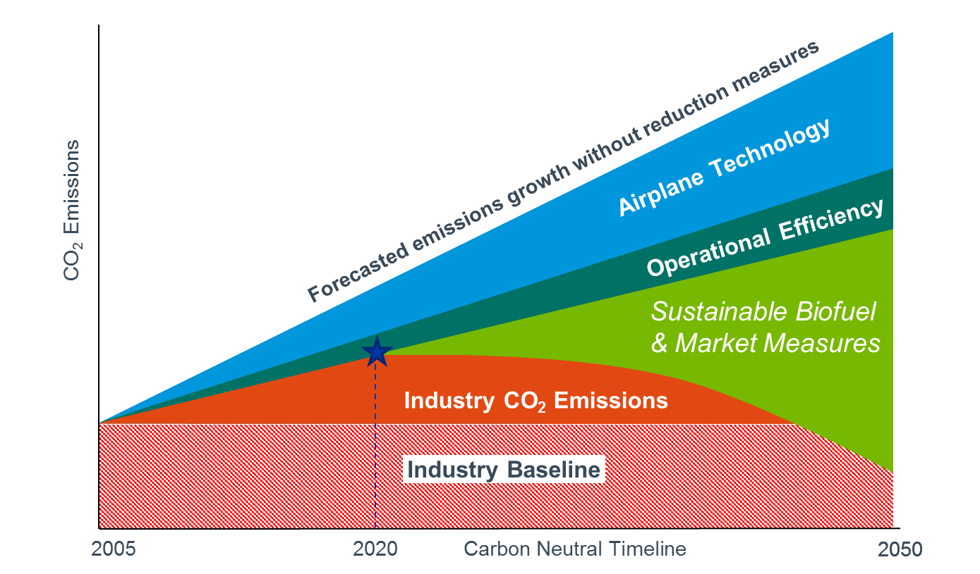

The figure above illustrates the anticipated impact of actions that are being taken by the aviation sector as it implements its climate plan. To meet the carbon neutral growth goal of 2020, international aviation has agreed on a global market based measure to put a price on international growth emissions. As shown in the figure above, it is anticipated that sustainable aviation fuels will play an important role in helping airlines achieve significant emissions reductions and meeting aviation’s climate goals.

3.3 Challenge
The global aviation industry has remained active in supporting the development of BioJet. The first BioJet flight occurred in 2008, and 10 years later, more than 100,000 flights have been operated using BioJet across the world. While several BioJet flights have occurred in Canada during that time, none of the BioJet was manufactured in Canada, to the disappointment of the Canadian aviation sector.
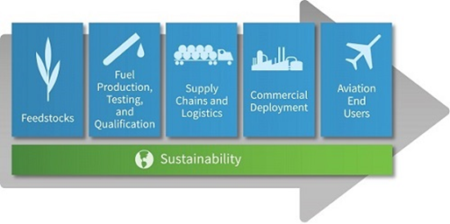
Figure 1 : BioJet value chain
In Canada, initial work has been done to assess specific regions, technologies and feedstock mixes that could form affordable BioJet value chains. While the results look promising, more work needs to be done.

It is important to ensure the sustainability and competitive advantage of an Alberta based value chain and manufacturing facility. To this end it is necessary to develop long term sustainable feedstock and conversion approaches for various feedstocks.

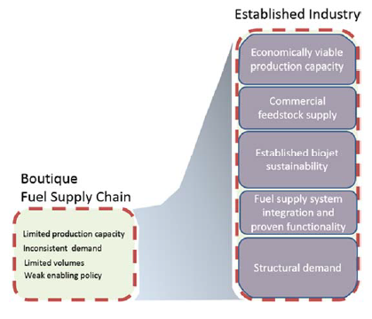
Figure 2 : Creating a sustainable BioJet Value Chain

Canada has demonstrated successes in creating new, value-added markets for its abundant natural resources that are socially and environmentally responsible. BioJet is positioned now to be one such Canadian success story but needs work to transition from a boutique fuel supply chain to an established industry and illustrated in Figure 2.

WestJet is pursuing an opportunity to issue a WestJet Biofuel Challenge via CCITF’s Clean Technology Commercialization (CT Comm) program funded by the Province of Alberta and WestJet to develop viable economical feedstock conversion technologies for the manufacture of BioJet fuel in Alberta, and to pursue further technology development and commercialization. It is recognized that no one feedstock found in Alberta may be available in sufficient quantity to meet the demands of any one airline.

The WestJet BioJet Fuel Challenge intends to create a sustainable and affordable BioJet value chain that will utilize/develop existing or emerging technologies, utilizing lower cost Alberta biomass, coupled with any other complementary efficient technologies to scale-up Alberta as a world leader in the bioJet industry.

Subsequent work related to fuel certifications, sustainability requirements and other downstream logistics need be addressed later, but these issues will be similar for all potential technologies under consideration. We highly encourage and require proponents to develop an overall value chain strategy that may then seek funding from other sources as applicable.

Alberta Innovates in combination with WestJet and the SM applicants, will deploy up to $2,000,000.00 for a demonstration, pilot plant or commercialization of a bioconversion technology(s), that can use Alberta sourced feedstock, leading to the manufacturing of a sustainable, certifiable, economically viable sustainable aviation fuel or BioJet. At minimum, the technology should produce sufficient volume to perform a jet fuel specification laboratory analysis in compliance with CGSB 3.23-2018.

It is understood this challenge does not favor any one feedstock or production pathway to achieve a sustainable aviation fuel, except the conversion technology must be able to meet the criteria as outline in section 5.0 below and the feedstock supply must be largely sourced from Alberta.

4.0 Guide to Sustainable Aviation Fuel
For further information related to the opportunities and challenges in developing sustainable aviation fuel and to discover the other technology, operations and infrastructure improvements underway across the aviation industry, check out the following references:

Commercial Aviation Alternative Fuels Initiative, CAAFI
Air Transport Action Group “Beginner's Guide to Sustainable Aviation Fuel”
International Energy Agency Task 39 report “The potential and challenges of drop-in biofuels”

This section is intended to give the reader the status of current sustainable aviation fuels production pathways and is not intended to imply that these technologies are the only ones that might be brought forward for consideration.

5.0 Technology Requirements/Deliverables
Due to the stringent regulation of jet fuel and high investment in current jet engine technology as well as the supply infrastructure, the aviation industry requires a solution that is a drop-in, sustainable and an affordable fuel alternative to petroleum jet fuel. Therefore, BioJet fuel technology should fulfil the following requirements to have any significant impact:

- Flexibility in feed stock processing, as even the same type of feedstock from renewable sources can vary in composition; for instance, vegetable oils can have different levels of unsaturation and acid content.
- Feed stock supply must be primarily available within Alberta.
- Installation and manufacturing to occur in Alberta.
- Should meet jet fuel specifications, especially freezing point, thermal stability and energy content.
- End products should have ability to meet quality and safety requirements, have a path to get ASTM certification/approval (or equivalent CGSB 3.23-2018).
- Should be a drop-in replacement for petroleum-based jet fuel and, demonstrate that it could meet generally accepted sustainability principles.

Production, operating, and maintenance costs should be competitive with petroleum jet fuel and show a pathway for the entire value chain being competitive with petroleum jet fuel.

6.0 Challenge Process
The applicant for this challenge must be a qualified Alberta SME company. The application process for this Challenge will take place in three phases:

Phase I: Expression of Interest (EOI) - Opportunity Identification

This phase is open to all Alberta based SMEs and will require all applicants to submit an Expression of Interest (EOI). The EOI application will be found on the CT Comm web page. The EOI will assess identified bio conversion technologies that align with the Challenge. Internal and external reviewers, including WestJet will be selected to evaluate these EOI applications.

Phase 1 – Evaluation Criteria – Call for Applications

Evaluation for Phase 1 will focus on:

- Technical/economic feasibility of the proposed bioconversion strategy outlining, including estimates of feedstock delivered cost within discussion of the economics
- How the bioconversion technology would fit into an overall supply chain, / long term viability within the entire value chain
- A viable path to market, that will have a significant impact in Alberta within a reasonable timeframe, and where applicable clearly defined competitive advantages/competitive sustainability
- Ability to meet quality and safety requirements, path to achieve ASTM requirements and other needed regulatory approvals
- Applicants’ access to funding and funding plan (developmental and project)
- Overall development plan and schedule, with a focus on track record of team

Phase 2: Corporate and Capital Readiness
This phase is a Full Project Proposal (FPP) stage and is by invitation only, with successful participants being selected from the Phase 1 EOI application.

- Applicants will be required to submit their up-to-date year-end financial statements.
- Applicants must submit a 5-year financial forecast, including a business plan
- Applicants will be required to submit an in-depth marketing/commercialization proposal outlining the development/demonstration of their technology in collaboration with any appropriate partners, including academia or other industry service providers, as well as letters of support (if applicable)
- The FPP stage will include site visits by AI and WestJet, and demonstration of technology if feasible
- A full work plan/schedule (milestones and budgets)

Phase 2 - Evaluation Criteria
The scope of this challenge is focused on supporting the development and demonstration of viable near-market technology solutions for the bio conversion of multiple feedstocks into aviation grade biofuels; that meet or exceed existing and anticipated regulations.

The solution provider must be a qualified Alberta SME and should have the capability of supporting their product through its lifetime (design, parts, maintenance, training, etc.). Broadly, the evaluation criteria will focus on:

The Opportunity.
- Market; The optimal solution and provider will be strongly positioned to address a clearly characterized and quantifiable market that is significant both in Alberta and globally
- Technology; The optimal solution will be sufficiently developed to ensure a timeline to field demonstration in a 1-3-year timeline
- Business; The optimal solution will be commercialized by an Alberta SME with the experience, expertise, planning and financial resources to realize the potential of the technology as well as the capacity to support the product through its lifetime (design, parts, maintenance, training, etc.)

The Impact to:
- Alberta; The impact to Alberta will need to be significant, measurable, and timely. The impact will include reducing emissions and enhancing economic development and job creation through new venture creation, manufacturing facilities and/or direct supply-chain growth and maturation
- SME; Growth is expected in the form of increased revenue, new export market/customer acquisition, recruitment and retention of highly skilled workers, and follow-on investment
- Environment; Technology opportunities must provide sufficient GHG reductions to meet or preferably surpass pending regulations to ultimately enhance the sustainability of Alberta’s environment

Project Feasibility.
- Outcomes; The project must be outcome-focused with appropriate milestones, timelines, and resource allocations
- Support; The project must have the appropriate supports in place, including partners and financing needed to ensure success

Phase 3: Go-to-Market Plan

This stage is by invitation only, with successful participants selected from Phase 2. As mentioned previously, a full work plan/schedule. Milestones and budgets will have been developed, and contracts based on this information would be entered before proceeding with the project. Alberta Innovates and WestJet will perform site visits as required.

Phase 3---Funding Criteria

The results from the Phase 2 work will be assessed and the ability to meet the criteria set out for Phase 2 above will be re-visited. The successful applicant(s) for Phase III will be able to demonstrate a strong probability of meeting such criteria.

Co-funding Opportunity
It is noted that successful SME proposals of this challenge are encouraged and are not precluded from engaging or participating in other funding opportunities; but may be subject to certain public-sector funding caps between the various programs. Full disclosure of participation in any other public-sector funding is mandatory.

