PROGRAM GUIDE: VOUCHER PROGRAM
program overview
Background
The creation of new technology and knowledge-based products and commercializing that innovation is critical to Alberta’s global competitiveness. Reducing time to market and taking a product to commercialization is an explicit priority for technology and knowledge-based research and development. Access to non-dilutive funding that de-risks technology or knowledge-based product development has been identified as a critical success factor.
Alberta Innovates developed the Voucher Program (the “Program”) to encourage high potential, high growth Small/Medium Enterprises (“SMEs”) with novel, promising technologies, strong management and an identified product/market fit to accelerate new product commercialization. The purpose is to de-risk feasible technological solutions, support emerging technologies and serve as a catalyst for the development and implementation of innovative technology products that can generate economic, social and environmental benefit for Albertans.
The Voucher is part of a suite of SME funding programs focused on the commercialization of these technological solutions and funded by the Government of Alberta, Ministry of Economic Development, Trade, and Tourism and administered by Alberta Innovates.
Program Details
Alberta SMEs (the “Applicant”) may be eligible for a Voucher within the range of $10,001 to $100,000, which is paid directly to up to three (3) Service Providers named in the Application. The Program is designed to support technologies in the mid-to-late developmental stages but may include some early developmental stages (See Technology Readiness Levels).
The Voucher is intended to fund the Applicant to work in collaboration with up to three (3) Service Providers to advance the technology closer to commercialization. Activities may include:
(a) New product research and development;
(b) Leading-edge design, engineering and prototype development;
(c) Advanced product testing and refinement;
(d) Patent development; (not including patent maintenance fees)
(e) Advanced market assessment or segmentation analysis;
(f) Advanced business and/or marketing strategies; and/or
(g) Other technology development activities may be considered on a case by case basis.

Vouchers are intended for technology and knowledge-based firms that have a reasonable expectation of growth, and exports to generate increased revenue and follow-on investment.
HOW THE PROGRAM WORKS
An Applicant may apply at any time, as this Program has continuous intake. Applications may be accessed through our Applicant Portal and Applicants can expect to receive the results within seven weeks after a complete Application is received. The support of a Technology Development Advisor (TDA) is strongly recommended.
Eligibility
(a) Applicant Eligibility Criteria - To qualify as an Applicant, an SME is required to satisfy the following criteria:
- be a for-profit SME;
- demonstrate the relationship between the Applicant and Service Provider does not create a conflict of interest;
- have a physical presence in Alberta;
- meet the following definition of an SME: a company with fewer than 500 Full Time employees, and less than $50,000,000 annual gross revenue;
- be a legal entity:
- incorporated in Alberta; or
- incorporated federally or in another jurisdiction AND extra-provincially registered in Alberta; or
- a General Partnership, Limited Partnership or Limited Liability Partnership AND registered in Alberta; and
- be in good financial standing with Alberta Innovates and its subsidiaries InnoTech Alberta and C-Fer Technologies.
(b) Service Provider Eligibility Criteria - To qualify as an Service Provider, the following criteria must be met:
- be Arm’s Length from the Applicant (cannot have any legal relationship with the Applicant);
- provide the service(s) and/or product(s) at reasonable market rates;
- be legally permitted to enter, remain in, and perform the services in Canada during the Project Term; and
- be in good financial standing with Alberta Innovates and its subsidiaries InnoTech Alberta and C-Fer Technologies.
(c) Project Eligibility Criteria
To qualify for funding all Projects must:
- be stepped with critical “go/no go” milestones;
- be completed within the two-year term; and
- submit to other criteria that Alberta Innovates may develop from time to time.
Program Objectives and Performance Measurement
The Voucher Program is designed to deliver meaningful return on investment to the Province by serving as a catalyst for the commercialization of innovative technology products for export that generate jobs, diversify the economy, and result in increased revenue for Alberta technology SMEs.

Over the life of a Project, Alberta Innovates employs an active project management philosophy, regularly monitoring performance and supporting the Applicant to reach their objectives. Funding is tied to outcomes and achievement of results. This means the Applicant is expected to submit a Progress Report before Alberta Innovates advances the next tranche of funds.

Once Projects are completed, Alberta Innovates continues to monitor performance to accurately evaluate the economic, social and environmental benefits realized for the province.
All Investment Agreements outline performance indicators tracked over the course of the Project and the responsibilities of the Applicant to report on outcomes subsequent to the completion of the Project. Alberta Innovates has a common set of performance metrics it monitors, both at the individual Project level and for the aggregate Program. These are highlighted on the next page.
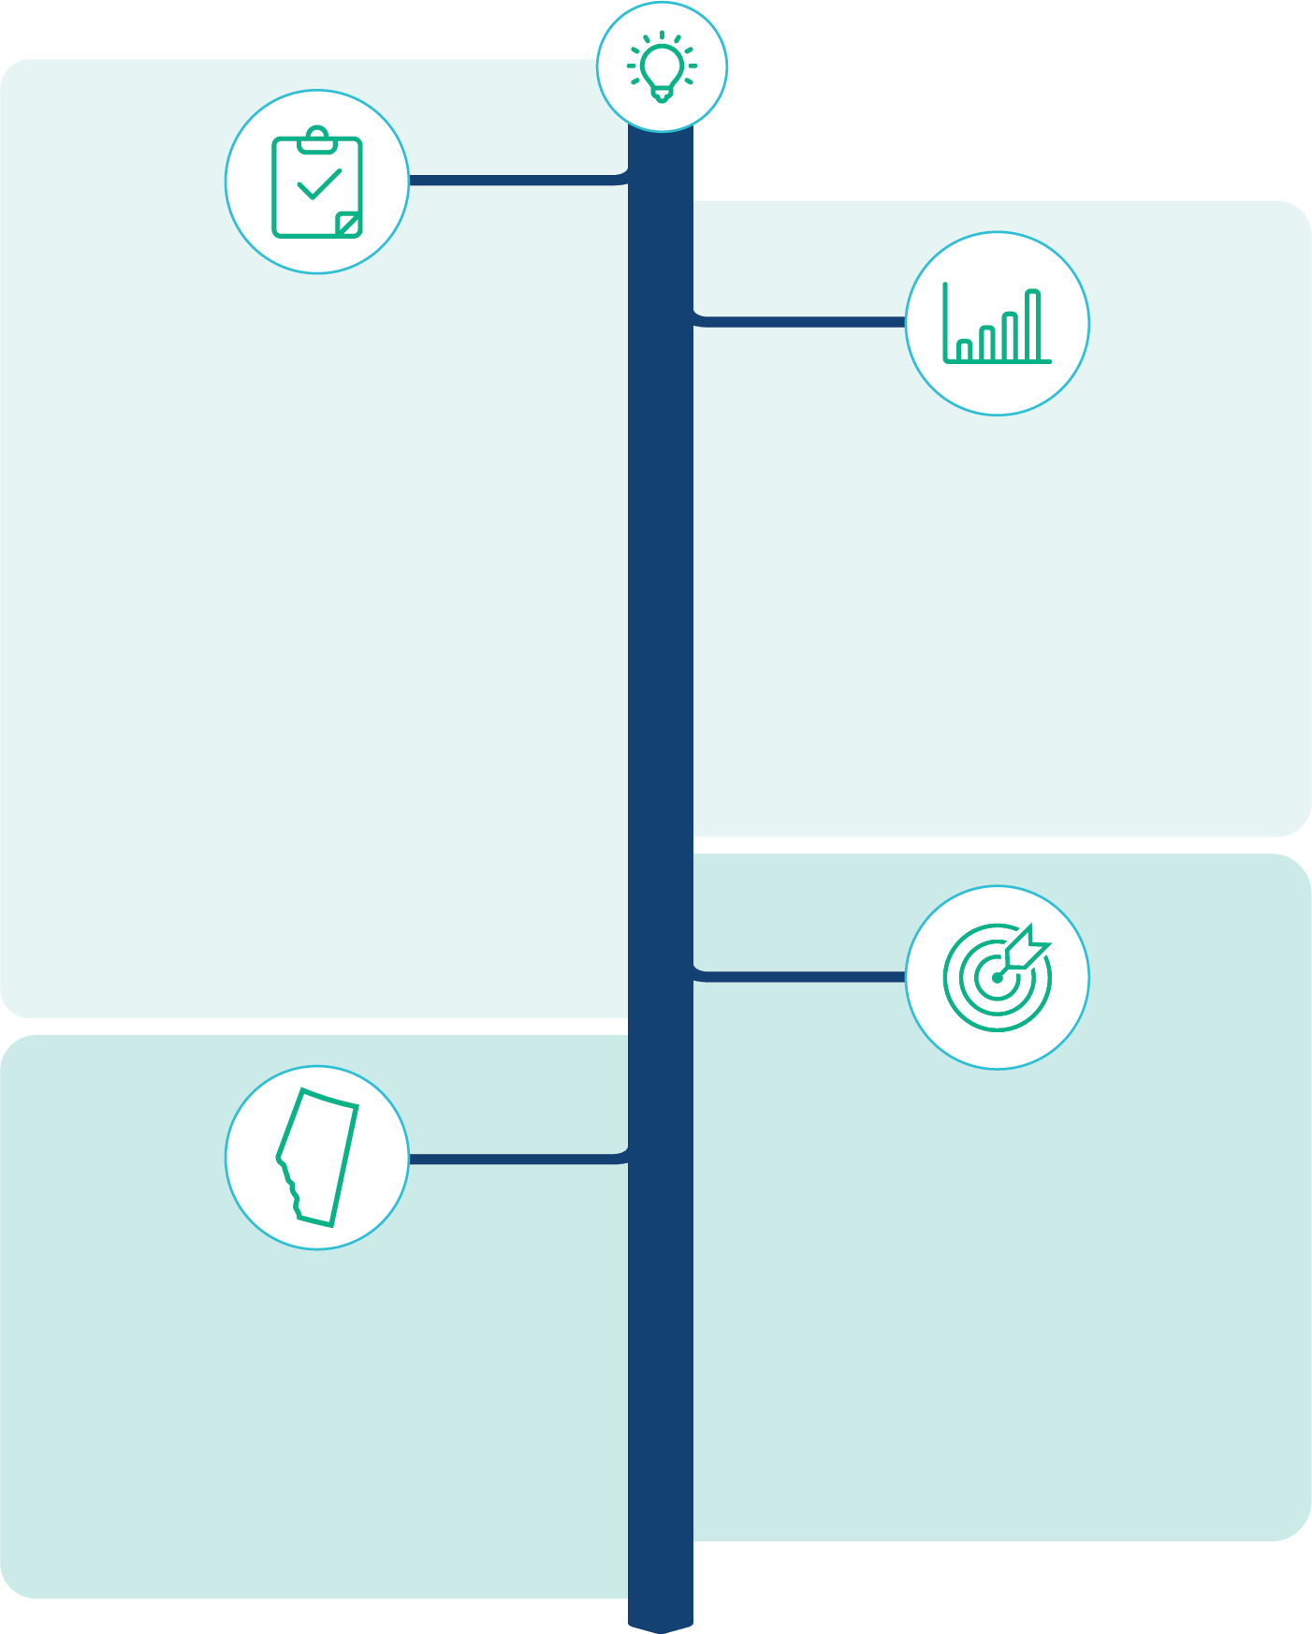
Objectives and Performance Metrics
PROGRAM SHORT TERM OUTCOMES
Advancement of SME’s Technology Readiness Level.
Progress toward product commercialization
Satisfaction rates of the SME

PROGRAM PERFORMANCE INDICATORS
Net jobs created
Revenue generated
Exports
Follow-on investment secured
Technology progression & scale-up
Economic diversification
Socio-environmental benefits to Alberta
ALBERTA OBJECTIVES
Increased technology industry Business Development activities & Outcomes
Globally competitive SMEs and large scale enterprises

LONG TERM
SHORT TERM
SME OBJECTIVES
Access to financial resources to accelerate commercialization
Access to business expertise to progress technology readiness level
Access to business expertise to progress to commercialization

How Funding Works
(a) Project Funding
Alberta Innovates’ Investment to a successful Applicant is within the range of $10,001 to $100,000, which is paid directly to the Service Provider(s) named in the Application. The Applicant pays a minimum 25% cash contribution (the “Contribution”) of the total eligible Project Costs, which is distributed throughout the milestones as agreed upon by the Applicant and the Service Provider(s). The funds are provided to cover Eligible Expenses only.
Alberta Innovates’ Investment is dispersed upon receipt and approval of a Progress or Final Report, over the maximum two-year term.

Alberta Innovates encourages co-funding of Projects with other funding agencies but employs a stacking limit to ensure there is sufficient financial commitment from the Applicant. The stacking limit is employed as follows: the maximum level of total government assistance, whether from federal, provincial/territorial, or municipal sources, cannot exceed 75% of the eligible Project Costs.
(b) Eligible and ineligible expenses
Alberta Innovates only funds reasonable costs incurred subsequent to a signed Investment Agreement between Alberta Innovates, the Applicant and the Service Provider(s). Any costs incurred prior to the signing of the Investment Agreement, or costs greater than market prices are deemed ineligible. Please refer to our standard form Investment Agreement found on our website to get an in-depth understanding of eligible and ineligible costs.
The chart on the next page provides a high-level summary of eligible and ineligible expenses.

Summary of Eligible and Ineligible Expenses
Category | Eligible Expenses | Ineligible Expenses
Labour | - Labour costs for those individuals specifically identified as performing the service for the service provider | - Overhead costs charged to employee labour rates
Materials | - Reasonable costs of materials which can be specifically identified for use in the Project | - Sales and marketing collateral
Capital Assets  & Software | - Software critical to the Project will be considered  - Other capital assets critical to the Project will be considered on a case by case basis | - Acquisitions of land or buildings  - The undepreciated value of eligible capital costs which extends beyond the Project term  - Capital Improvements  - Capital Equipment
Travel and Relocation |  | - Costs relating to travel (including mileage and accommodation), meals, entertainment, hospitality and gifts  - Passport or immigration fees  - Reimbursement for airfare purchased with personal frequent flyer programs  - Commuting costs between place of residence and place of employment
Other | Costs which Alberta Innovates pre-approves in writing as an eligible expense | - Costs associated with applying for government grants and programs  - Technical or professional journals  - Provisions for contingencies  - Collection charges, allowance for interest on debt, fines and penalties  - Federal and provincial income taxes, goods and services taxes  - Expenses for Projects or activities outside the approved Project  - Costs which Alberta Innovates deems ineligible at its sole discretion
HOW TO APPLY
STEP 3
Project Management
For approved Applications, the Applicant and the Service Provider(s) will execute an agreement with Alberta Innovates to proceed with the activities of the Project.
On-going management, reporting of milestones and payments on each milestone based on achievement of the objectives.
A TDA will be assigned to the Project if one is not already engaged.
Alberta Innovates continues to require information from the Applicant for five years following the completion of the Project in order to measure long-term benefits.

STEP 1
Project Scoping
An Applicant identifies the Project need and obtains quotes from up to three service providers to complete the Project.
TDA’s are available to provide coaching, advising and networking during this phase.

STEP 2
Application & Evaluation
Alberta-based SMEs can submit their Applications online at any time.
Applications outline the Project, the participation of Service Providers, the benefits, the Applicant’s business readiness, and the Project finances.
Alberta Innovates’ merit review focuses on the technology, the opportunity, the management team, and the overall success and size of the return to Alberta against the Performance Indicators listed on page 4.

EVALUATION PROCESS
Alberta Innovates leverages internal staff and external expert reviewers to evaluate Applications submitted by SMEs. Alberta Innovates evaluates promising technologies based on a variety of common business and technical factors such as: the management team, market conditions, competitive advantage and product/market fit, go to market plan, financials, technical feasibility and export potential.
Alberta Innovates retains the sole right to determine the evaluation process and does not disclose the names of its external reviewers to ensure their objectivity and impartiality. All external parties are subject to both confidentiality and conflict of interest policies set by Alberta Innovates.
An Applicant whose Application is declined by Alberta Innovates may, on a one-time basis, re-apply to Alberta Innovates to address and correct any deficiencies or issues. Where a shareholder of an Applicant owns 51% of any other Applicant, as indicated by the corporate search, the Applicants will be considered one in the case of a re-application where the Project or technology is the same.

Terms and Conditions
This Program Guide is intended as a high-level overview of the Voucher Program. It provides interested SMEs with a roadmap of what to expect over the lifecycle of a Voucher Project, from the application stage, during the Project, and post-completion. Please be aware Alberta Innovates may modify this guide from time to time in keeping with any changes to the Program.
Alberta Innovates will only correspond in writing and provide copies of the Application to the person named in the application form as the one authorized to speak for the Applicant.
Once we have evaluated and approved application for funding, Alberta Innovates will require the Applicant and the Service Provider(s) to sign a standard form Investment Agreement. A copy of the Investment Agreement is available on the Alberta Innovates website’s Voucher Program webpage. The Investment Agreement sets out in detail the roles, responsibilities and obligations of the various Parties to ensure a successful Project. Alberta Innovates will not provide any funding until the Investment Agreement has been signed by all Parties.
Alberta Innovates will only fund Applicants who have satisfied all eligibility criteria. Meeting the eligibility criteria does not guarantee access to funding, and all funding decisions will be made by Alberta Innovates at its sole discretion.
Contact Information
Should you have any questions about this guide or the Voucher Program in general, please contact Alberta Innovates at inbox_grants@albertainnovates.ca .

To reach the Technology Development Advisor closest to you, please visit our website at https://connectwithus.albertainnovates.ca
Version 1.0 – January 2019

