
Learn how albertainnovates.ca








I
This project focuses on two areas: advancing Alberta’s top low-emissions economic opportunities and Alberta’s Electricity Future (AEF) solutions. Generate Canada through its subsidiary Energy Futures Lab, will advance this work through three key activities:
- Identify & Validate Opportunities & Barriers: apply engagement findings to assess cleantech regional opportunities & barriers
- Convene Ecosystem to Unlock Opportunities: align cleantech growth strategies and support clean electricity stakeholder coordination to broaden perspectives and approaches to solutions.
- Solution Development & Implementation: support solution development and implementation for electricity system decarbonization, and for low-carbon industry growth.
Mobilizing Alberta’s Clean Energy Economy
This project aims to advance emerging industries, drive coordinated clean electricity system action, and increase the ‘will to act’ by aligning diverse groups around emerging low-emissions economic opportunities, informing policy and regulatory changes, and creating attractive investment environments.
PROJECT TRL:
N/A – Ecosystem Development Program
PARTNERS:
RBC Foundation, Various Industry, Government, and Community Organizations
TOTAL BUDGET:
$1,600,000
AI FUNDING:
$500,000
RECIPIENT:
Generate Canada
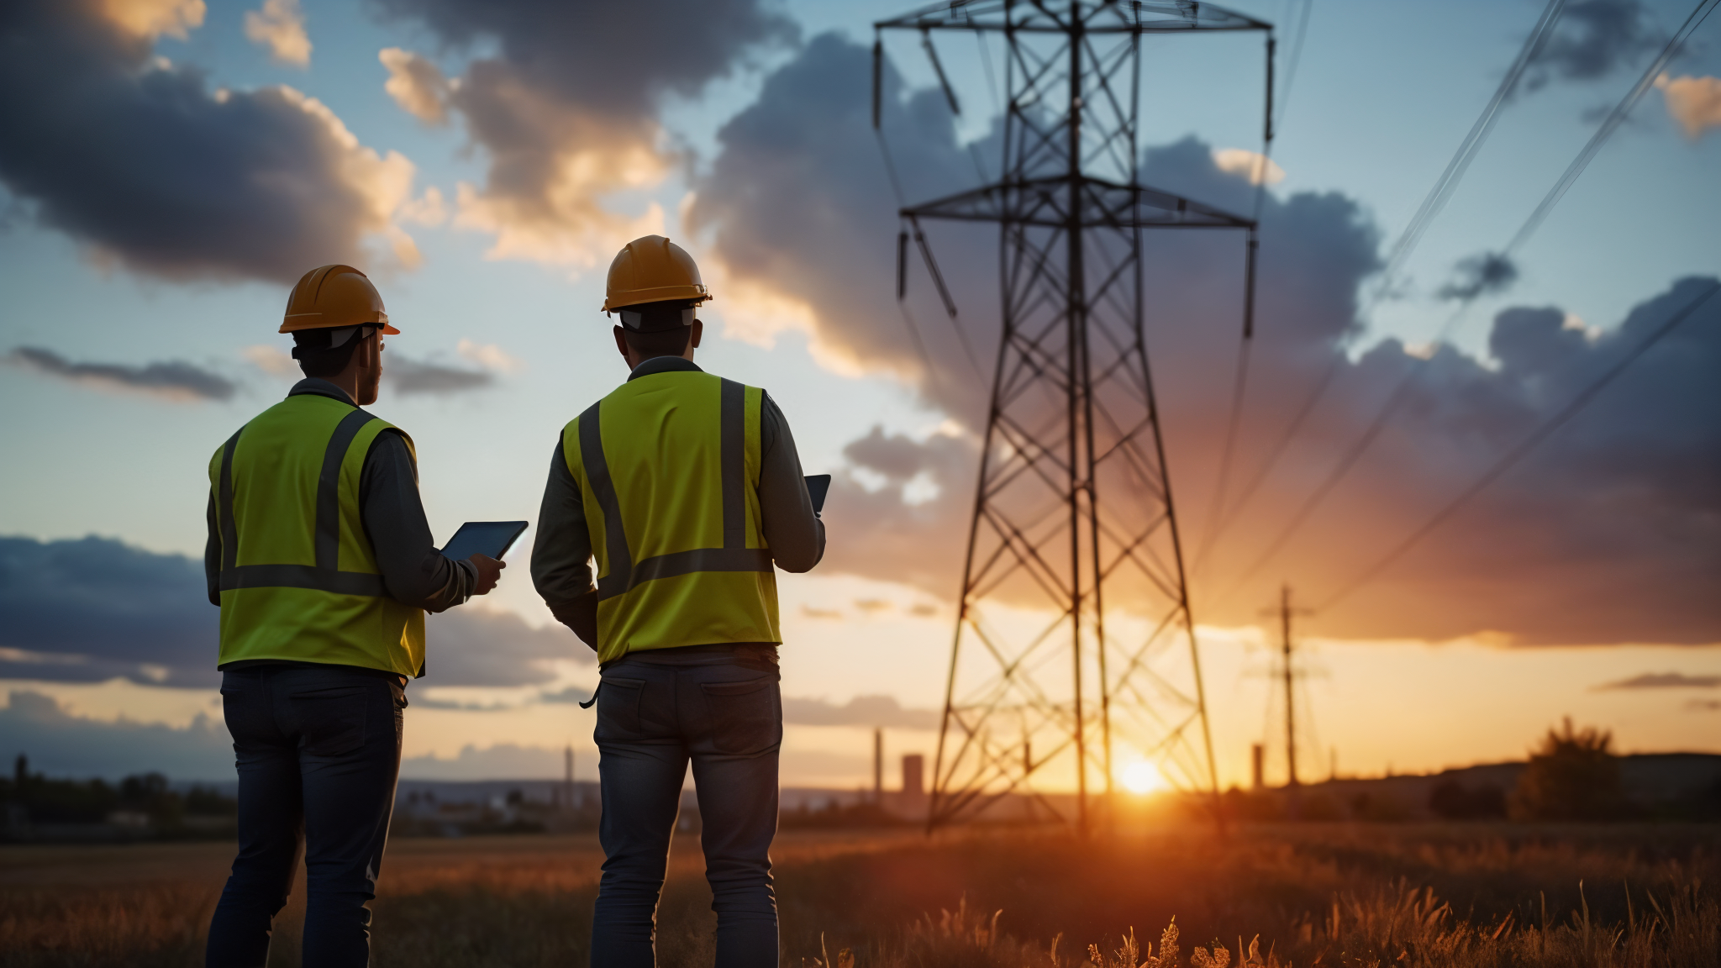
FUNDING DETAILS
Strategic Industries
Energy

RENEWABLE AND ALTERNATIVE ENERGY
PROJECT DATES:
MAR 2025 –
MAR 2028
APPLICATION








s
April 2026
AEF has completed Round 1 of solutions focused on advancing demand response recommendations, distribution energy resources (DERs) policy framework and local market considerations. The work on these solutions helped advance a distribution policy recommendation package submitted to GoA in May. Calgary-Edmonton Corridor clean tech opportunities regional engagement workshops concluded with a focus on lithium opportunities. Additional engagement opportunities for Peace River-Greenview Region planned for 2026.
AEF:
- Accelerating decarbonization and modernization of Alberta’s electricity system
- Developing and implementing new solutions based on emerging policy windows
- Holistic solutions are being implemented based on diverse system perspectives and needs
- Electricity system champions are influencing decisions aligned with AEF Vision

Regional Cleantech Opportunities:
- 1-3 priority cleantech sectors identified within two regions in Alberta
- Collaborative projects in the two regions are attracting investments
- Regional stakeholders and rights holders have shared confidence in cleantech development processes

Enable
Future Jobs

5 Project Jobs
1 Students Trained
Enabling Future GHGs Reductions

Enabling Project GHGs Reduced
0 New Product/Service
0 Patents
The project activities will strengthen greater alignment of economic priorities and effective working relationships between ecosystem actors, as well as increased connectivity across sectors and regions. This project is an enabler of various impacts, including:
- Clean energy and emerging sector growth
- Potential investment attraction
- Supporting economic reconciliation
- Low carbon and decentralized electricity generation
- Reducing GHG emissions
- Developing new revenue streams for rural and Indigenous communities
- Maintaining Alberta’s leadership position in the energy system by leveraging regional strengths
- Progress towards developing robust clean technology industries

Disclaimer • Alberta Innovates (Al) and His Majesty the King in right of Alberta make no warranty, express or implied, nor assume any legal liability or responsibility for the accuracy, completeness, or usefulness of any information contained in this publication, nor that use thereof infringe on privately owned rights. The views and opinions of the author expressed herein do not necessarily reflect those of Al or His Majesty the King in right of Alberta. The directors, officers, employees, agents and consultants of AI and the Government of Alberta are exempted, excluded and absolved from all liability for damage or injury, howsoever caused, to any person in connection with or arising out of the use by that person for any purpose of this publication or its contents.

CURRENT STATUS

PROJECT GOALS
BENEFITS TO ALBERTA
Strategic Industries
Energy

[BUSINESS UNIT]
[PROGRAM]
[SUB-PROGRAM]

