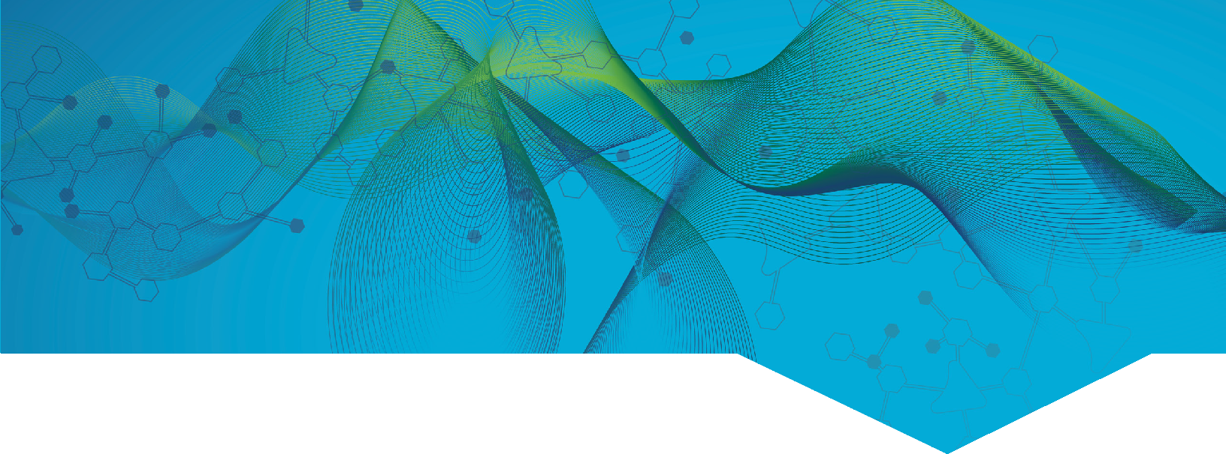
Learn how albertainnovates.ca

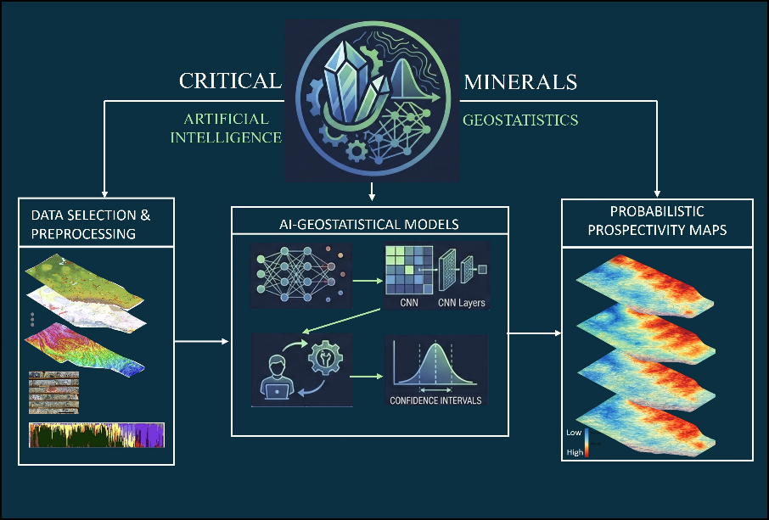







Strategic Industries
AEROSPACE, DEFENCE & ADVANCED MATERIALS
Minerals
Researchers at the University of Alberta aim to develop an integrated, artificial intelligence-driven geostatistical framework using advanced machine learning to model complex spatial patterns, combine diverse Earth datasets, transfer knowledge to data-poor regions, and quantify prediction uncertainty to develop probably critical mineral maps for Alberta. The project will use existing geophysical, geochemical, hyperspectral, and remote-sensing datasets to inform the model and will be cross-validated against existing data and maps provided by the Alberta Geological Survey. Deliverables include reproducible workflows, probabilistic 2D and 3D maps, and interactive web-based layers.
Advanced Geostatistical and AI Workflows for Data-Driven Critical Mineral Prospectivity Mapping in Alberta
PROJECT DATES:
Dec 2025 –
MAR 2027
RECIPIENT:
University of Alberta
TOTAL BUDGET:
$606,000
The project will focus on evaluating and mapping four priority mineral zones within Alberta including the Canadian Shield, Athabasca Basin, Birch Mountains, and Clear Hills. Minerals of interested to be targeted within these regions include vanadium, nickel, lithium, rare earth elements (REEs), titanium, magnesium, uranium, cobalt, copper, zinc, and potash.
PROJECT TRL:
Start: 4
End: 7

AI FUNDING:
$180,500

PARTNERS:
Alberta Geological Survey
APPLICATION
FUNDING DETAILS





s
- To develop tested, validated, and reproducible AI-based modelling workflows to identify areas of mineral potential.
- Generate 2D and 3D models combining multi-modal datasets
- Generate mapped areas of inferred mineral potential in the four priority mineral zones for evidence of minerals and metals of interest
- Mapped areas will be hosted by the AGS.
- Develop skilled post-secondary workers through a collaborative post-secondary and industry learning opportunity
4 Students Trained
2 New Product
3 Publications
4 Project Jobs
Strategic Industries
AEROSPACE, DEFENCE & ADVANCED MATERIALS
Minerals

Disclaimer • Alberta Innovates (Al) and His Majesty the King in right of Alberta make no warranty, express or implied, nor assume any legal liability or responsibility for the accuracy, completeness, or usefulness of any information contained in this publication, nor that use thereof infringe on privately owned rights. The views and opinions of the author expressed herein do not necessarily reflect those of Al or His Majesty the King in right of Alberta. The directors, officers, employees, agents and consultants of AI and the Government of Alberta are exempted, excluded and absolved from all liability for damage or injury, howsoever caused, to any person in connection with or arising out of the use by that person for any purpose of this publication or its contents.

CURRENT STATUS

- New intelligent tools to help better identify areas of mineral potential within the province leveraging existing data
- Potential to influence more targeted future sampling programs to evaluate potential areas of mineral presence within the province
- Develop highly skilled workers within Alberta for the mineral exploration and extraction sector
PROJECT GOALS
BENEFITS TO ALBERTA
[BUSINESS UNIT]
[PROGRAM]
[SUB-PROGRAM]

March 2026
Project recently contracted and commenced.

